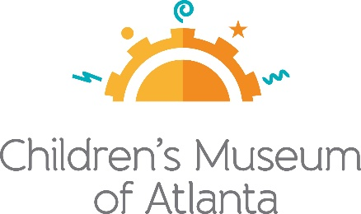

FOR MORE INFORMATION
Sarah Wynn Benton
BRAVE Public Relations
404.233.3993
sbenton@emailbrave.com
FOR IMMEDIATE RELEASE

Children’s Museum of Atlanta Names Kate McNeely Director of Strategic Advancement and Marketing

ATLANTA (April 9, 2024) – Children’s Museum of Atlanta welcomes Kate McNeely, CFRE as its new Director of Strategic Advancement and Marketing. McNeely joins the Museum with more than a decade of nonprofit fundraising, marketing and administration experience, most recently serving as Director of Development for Georgia Asylum and Immigration Network (GAIN). She will play a crucial role in advancing the museum's mission to provide interactive educational experiences for children and families in the Atlanta community.

"On behalf of all our staff and board members, we are delighted to have Kate join our team," said Executive Director Edwin Link. "She embraces the Museum’s mission and vision, and we are confident that she will lead our efforts and help us achieve our goals of providing enriching experiences for our kids and families."
As an advocate for early childhood education and community engagement, Kate has been actively involved in several philanthropic initiatives throughout her career. During her recent tenure with GAIN, she spearheaded communications efforts, and managed a complex annual development portfolio which included federal funding, private foundation funding, corporate giving, event fundraising and individual giving. Kate also gained invaluable experience through her former positions at Planned Parenthood Southeast, Inc. and the Woodruff Arts Center.
Her commitment to fostering creativity, curiosity and lifelong learning fits seamlessly as the Museum continues to give all children access to opportunities to grow and learn through the power of play. Kate has also served as a leader in the fundraising community; she is the Immediate Past President of the Association of Fundraising Professionals (AFP) Greater Atlanta Chapter, and has spoken locally and nationally about topics such as authentic leadership and ethical storytelling.
###
About Children’s Museum of Atlanta:
Children’s Museum of Atlanta is the only educational venue of its kind in Atlanta, presenting educational programs and exhibits designed for young children ages 0-8. The mission of Children's Museum of Atlanta is to change the world by sparking every child's imagination, sense of discovery and learning through the power of play. With learning zones consisting of bright, creative and hands-on exhibits, the Museum supports inventive play-based exploration and experiential learning focused on the whole child. Core competencies for literacy, math and science are promoted throughout all exhibits and programming in alignment with the state and national Core Performance Standards. Funding has been provided by Georgia Humanities and the National Endowment for the Humanities as part of the American Rescue Plan Act of 2021. For more information, please visit GeorgiaHumanities.org. Major support is provided by the Mayor's Office of Cultural Affairs and major funding is provided by the Fulton County Board of Commissioners. Children’s Museum of Atlanta also offers memberships. For more information or to support Children's Museum of Atlanta, visit childrensmuseumatlanta.org or call 404.659.KIDS [5437].

